Janice Ainembabazi

Southern New Hampshire University

CS-255 System Analysis and Design

Prof. Maureen Kinkela

October 20th 2024

# CS 255 System Design Document Template

## UML Diagrams

### UML Use Case Diagram

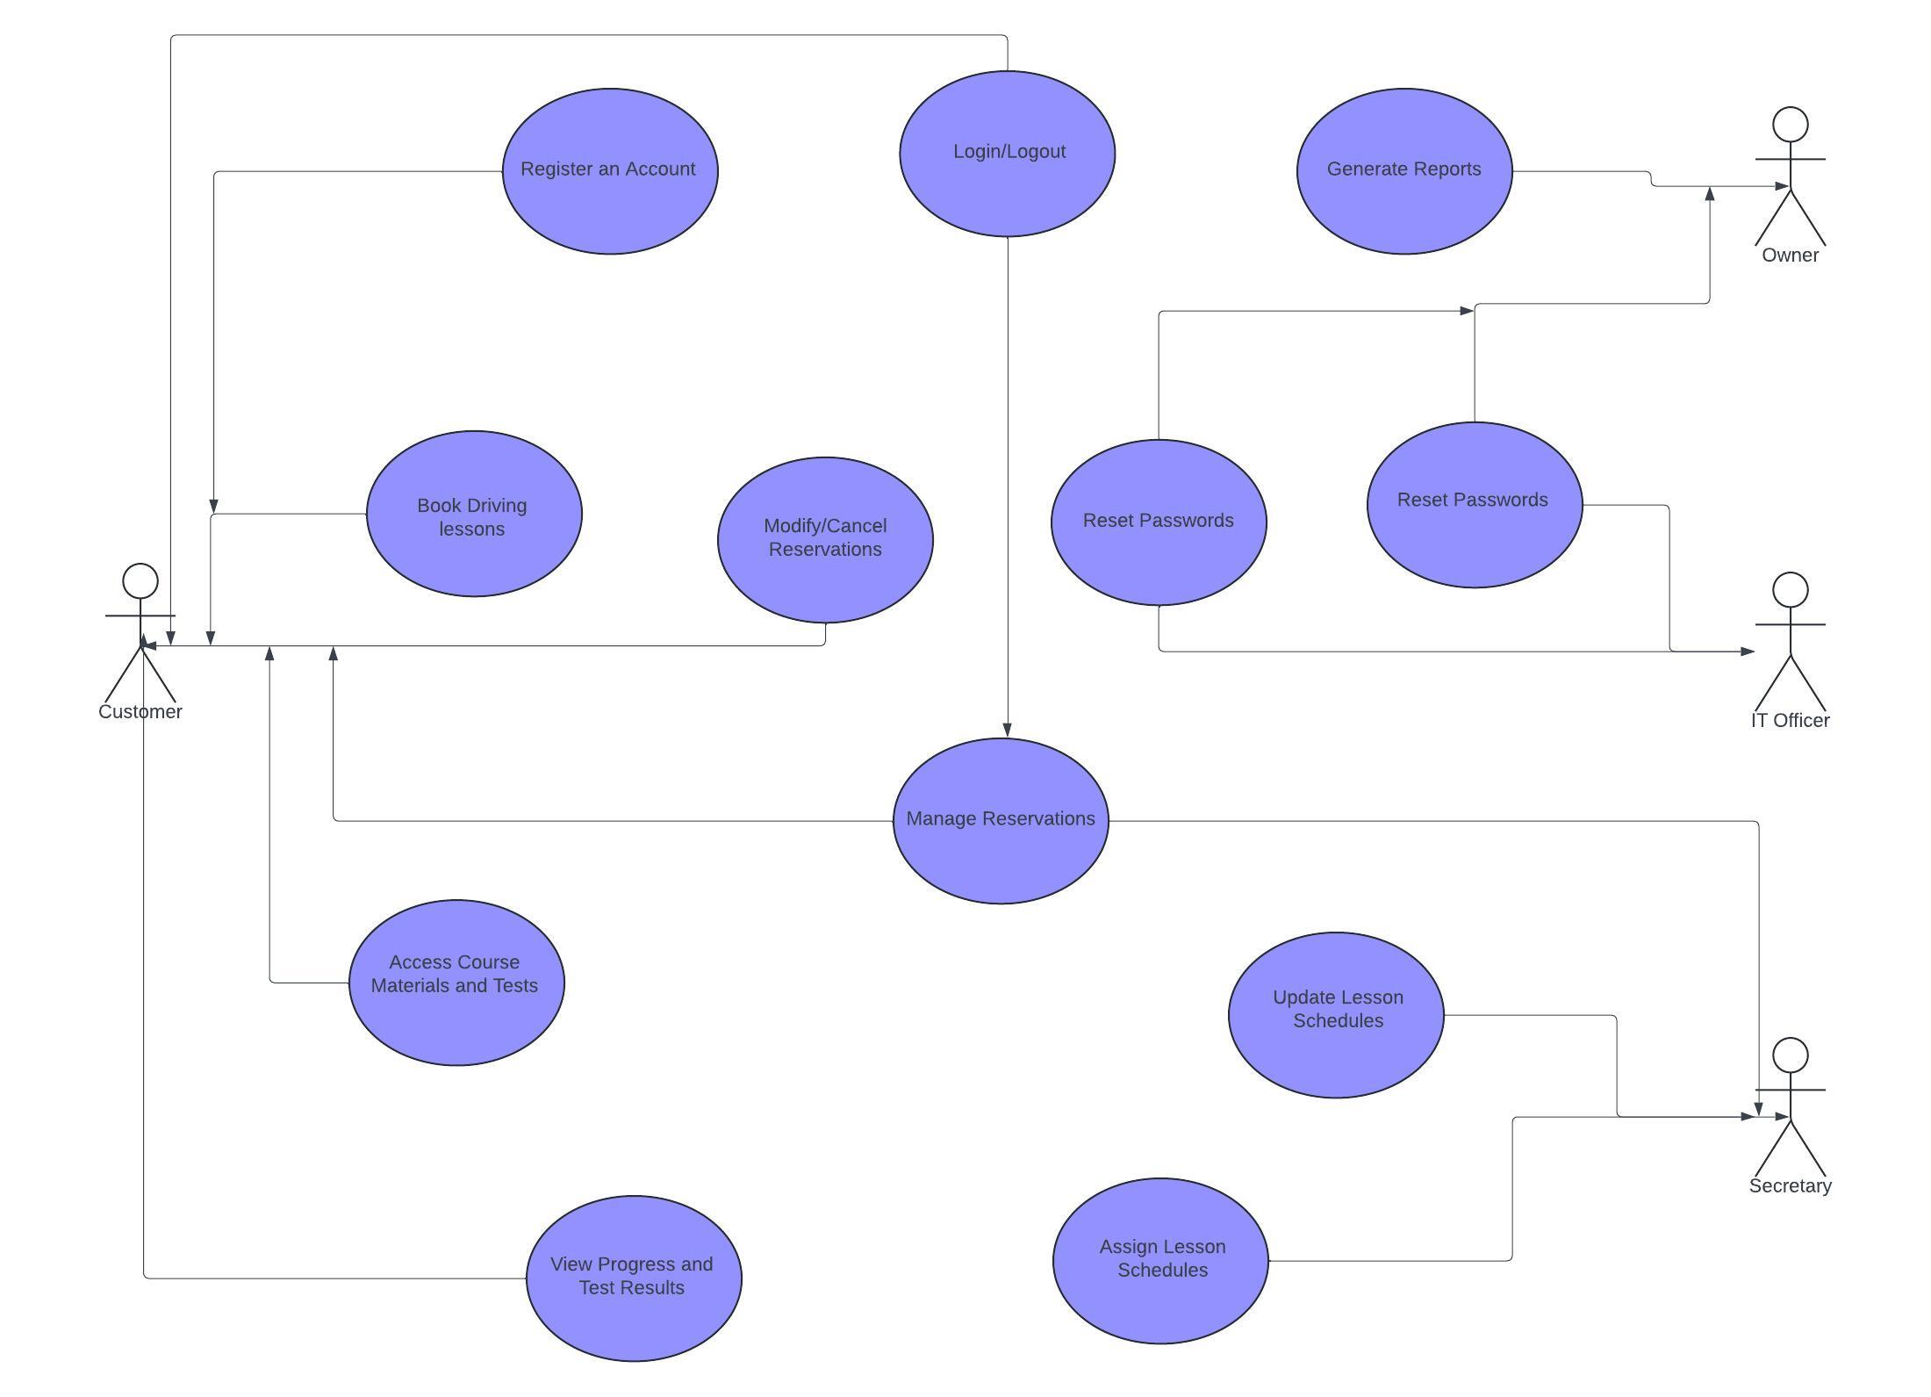

### UML Activity Diagrams

***User Activity Diagram***

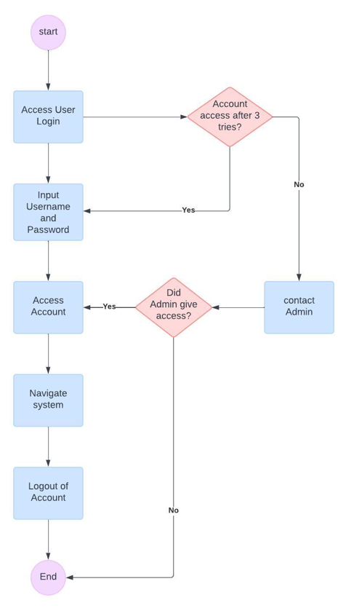

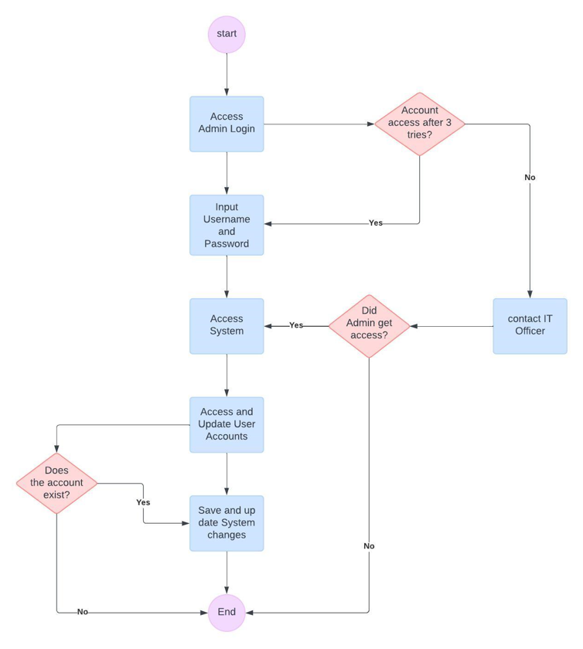

### UML Sequence Diagram

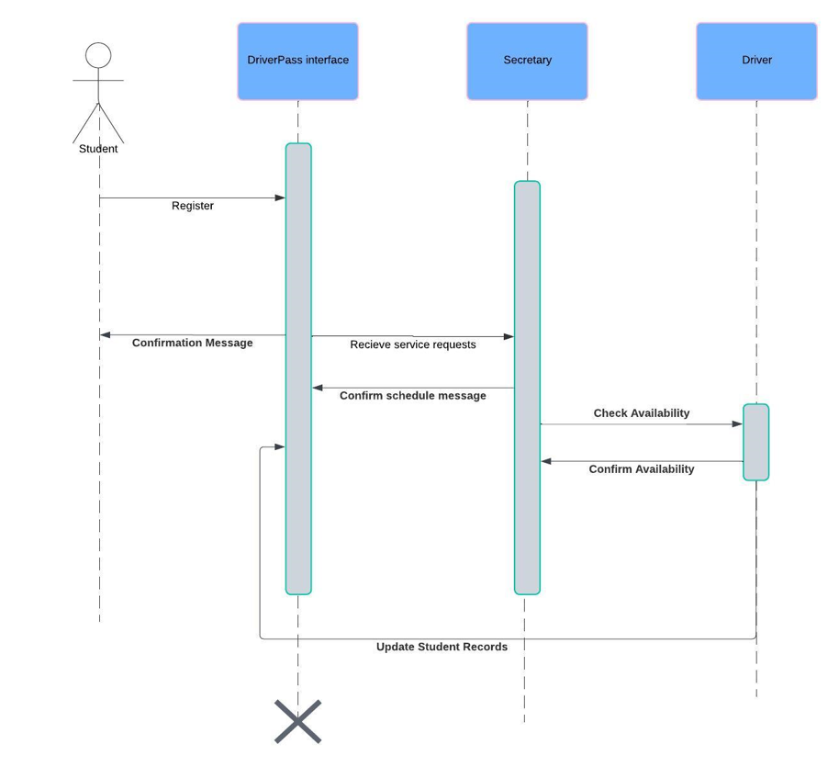

### UML Class Diagram

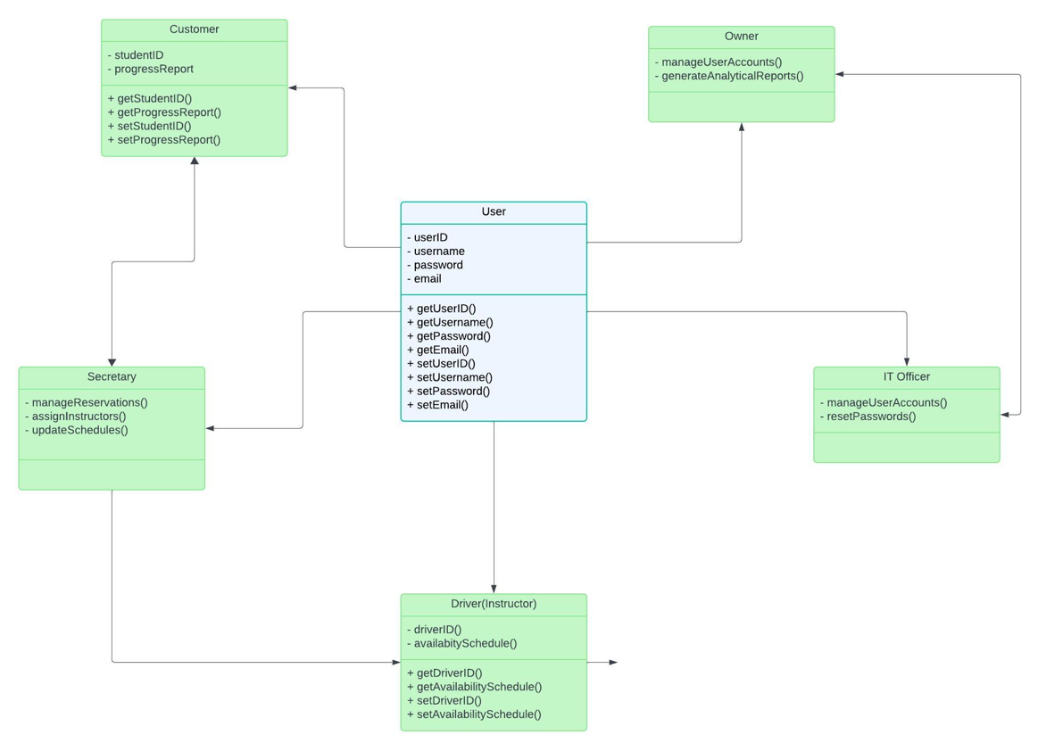

## Technical Requirements

I have to make sure the system I'm creating for DriverPass can accommodate a variety of users, including students, the owner of DriverPass, IT officers, administration, staff members like secretaries, and drivers and instructors. In terms of software, I would pick a stable object-oriented language that allows abstract classes and inheritance, such as Python, C#, or Java. I would use an IDE like PyCharm, Visual Studio, or IntelliJ IDEA to make development easier. In terms of data management, I would carefully design the database architecture to represent each user role and rely on a relational database like MySQL to safely hold user-specific data.

I might use frameworks like Django for Python or Spring Boot for Java when developing the back-end to ensure smooth server-side processing. Frameworks like React or Angular are good choices for the front end because they provide an easy-to-use interface that makes it simple for users to register, log in, and access features like scheduling and progress reporting.

Because security is important, I would utilize hash algorithms like bcrypt to safeguard passwords and implement JWT for secure authentication. For effective source code management, I would use Git for version control. Since testing is essential, I would use JUnit or other similar tools for thorough unit testing, with QA tools for user interface testing. Deployment could be either cloud-based or on-premise. When it comes to cloud services, platforms such as AWS or Azure provide flexible and scalable options. While an upgrade to 16 GB RAM could increase productivity, I would make sure development computers have at least 8 GB of RAM and a quad-core processor. CI/CD tools like GitHub Actions are what I would use to help development and deployment go more smoothly. System performance would be maintained with the use of monitoring tools like Prometheus and Grafana, while team cohesion and productivity would be maintained with the use of communication and project management platforms like Slack and JIRA. Building a system that is safe, scalable, and easy to use while satisfying the demands of its wide range of users is my ultimate objective.

**REFERENCE**

DuBois, P. (2014). *MySQL cookbook, 3rd edition.pdf*. [www.it-ebooks.info](http://www.it-ebooks.info). <https://www.luciopanasci.it/Ebooks/MySQL> Cookbook, 3rd Edition.pdf

Esposito, D. (2016b). Modern Web Development: Understanding domains, technologies, and user experience. <https://ptgmedia.pearsoncmg.com/images/9781509300013/samplepages/9781509300013.pdf>

Osherove, R. (2013, November). *The Art of Unit Testing, second edition*. O’Reilly Online Learning. <https://www.oreilly.com/library/view/the-art-of/9781617290893/>